How to set up a deferral on the oaretirement.com site
- go to oaretirement.com/login.aspx
  - if this is your first time logging in, you will need to register for a new account
    - click on Register for a new account box
    - you will have to enter your SSN, DOB and zip code
      - a multi-factor authentication code (MFA code) will be sent to your email address on file with the retirement company. if you don’t have an email address, you will receive a letter in the mail with the MFA code. You may also call the retirement company at 800-858-3829 for your MFA.
- When you first log in, you will be prompted to set up a one-time use PIN. It will be emailed to you and you will need to enter it in order to proceed.
- when the screen opens, notice the toggle bar on the top of the screen. It will automatically take you to your 401a employer match account (Yukon-Kuskokwim Health Corp. 401(a) Profit Sharing Plan).
  - You will have to change the toggle bar to “Yukon-Kuskokwim Health Corp. 403(b) Tax Deferred Annuity Plan”
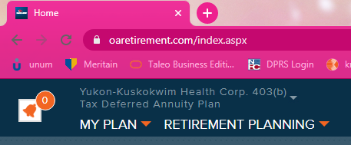

4) click on the “MY PLAN” column, on the top left screen and choose “contributions” under the Investment column

5) You may set up a contribution to either a Pre-Tax 403(b) account or a Roth (after tax) 403(b) account. Select the amount you want taken out every payday, and press Continue.
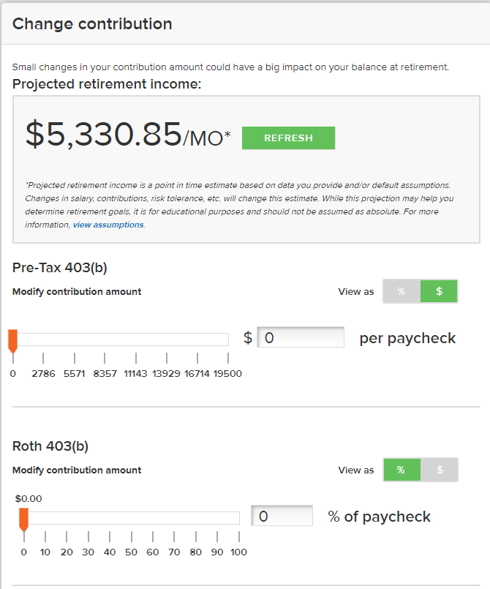

6) you will be prompted to verify the contribution, press SUBMIT CONTRIBUTION to proceed

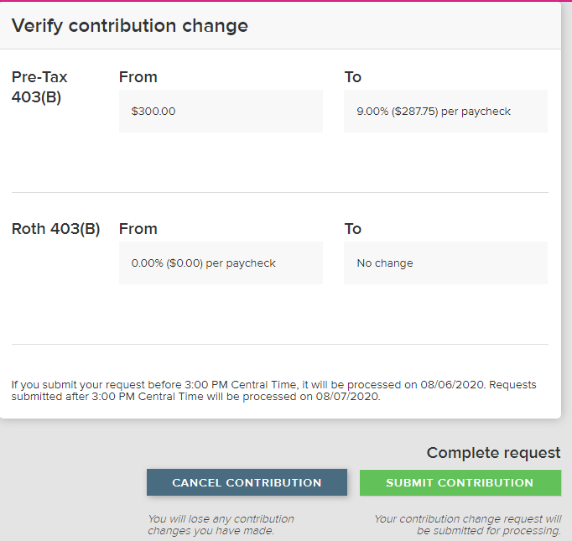

7) once the confirmation goes through, you will get a verification page
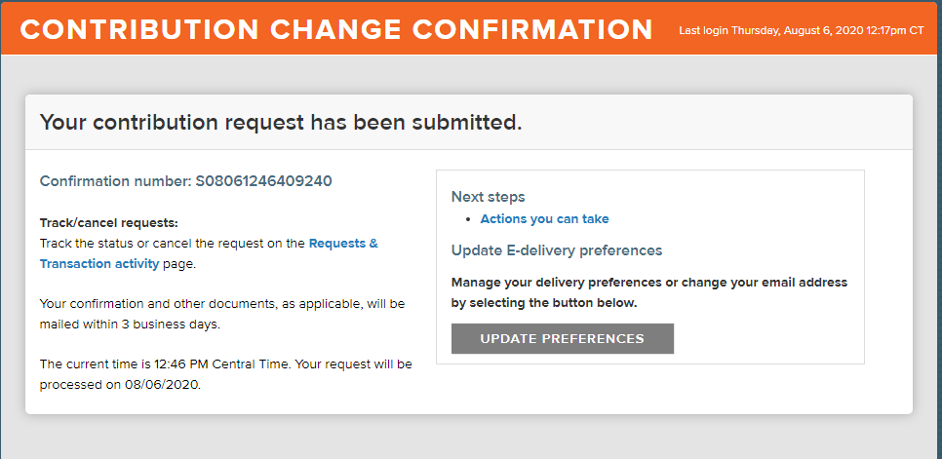

If you are having problems logging in, please contact OneAmerica at 1-800-858-3829. Otherwise, contact HR benefits at hrbenefits@ykhc.org

